

DIPLOMA IN INFORMATION TECHNOLOGY

COURSEWORK
SUBJECT: IT Project I– Initial Plan
SUBJECT CODE: DIT 2166

NAME | STUDENT ID
IVAN WONG ONN YEE | 20043246
WOO CHAN EE | 20035739

- Project Title
Currency Converter Website with Extra Features

- Project Description
Oftentimes when we are researching about countries abroad, we tend to open many tabs such as a currency converter, time zone changer, flight tickets and so on and so forth.
This website aims to encapsulate all the extra research one has to do into one single website. Users can start by converting two currencies i.e., MYR to USD and instantly it displays the currency, time of both countries, tourist attractions and so on and so forth.
With simplicity and convenience in mind, we plan to implement a flight ticket feature by hyperlinking an airline company from the host country. For example, a conversion from MYR to GBP will create a hyperlink which leads to Malaysian Airlines. We plan to only provide hyperlinks to the top Airline companies in their respective countries to ensure customer satisfaction.
We also plan to negate the use of physical tools such as a Calculator and Calendar by implementing a virtual Calendar and a virtual Calculator. We believe that the abundance of features available on our website can effectively retrench the mess and confusion associated with research and planning.

- Project Purpose
We plan to create a portal for all consumers who are interested in researching foreign countries or those who are simply deciding where to have their vacation.
This idea came to mind when I was doing research on my trip to Hong Kong a couple of years ago. I bought in to the hype of the beauty of Hong Kong through TVB dramas and decided to book a ticket there. However, I had to do plenty of research, which was cumbersome. That was when an epiphany came to me about designing and building a website with all the features encapsulated into one.
My partner and I envision this website to be a pioneer among future travel sites.

- Project Scope
In this project, we will make a website to contain the content we want to produce.

Currency Converter Website with Extra Features (Admin’s & User’s Views)
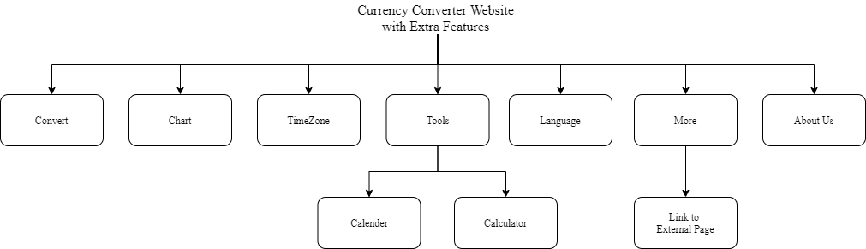

The Use Cases Diagram of Currency Converter Website with Extra Features
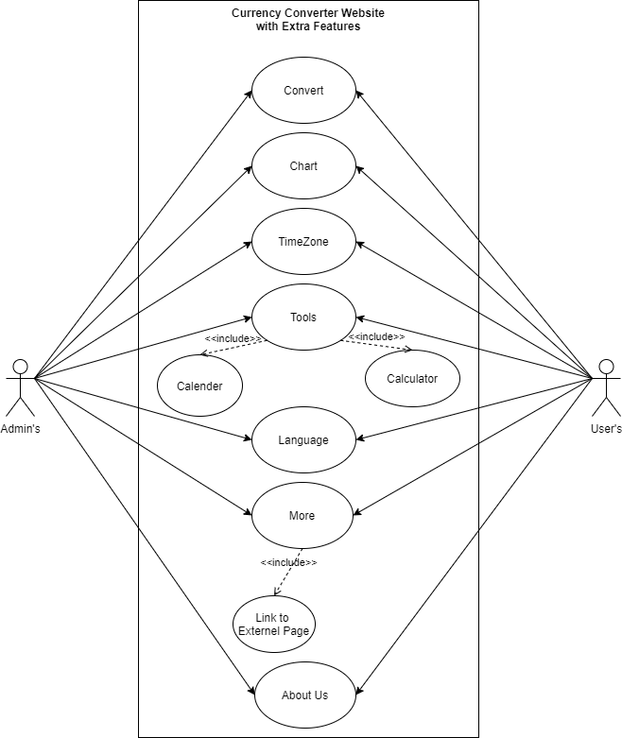

To produce: A website focused on providing users with a plethora of services relating to foreign countries and travelling.

Stated as a requirement: To set up a website that is able to satisfy all user’s demands without a fault.

5. List of Activities, Milestones, Timeframe
** Do note that we will build both pages for admin and user simultaneously
Activities / Tasks | Week
 | IT Project 1 |  |  |  |  |  |  |  |  |  |  |  |  |  | IT Project 2
 | 1 | 2 | 3 | 4 | 5 | 6 | 7 | 8 | 9 | 10 | 11 | 12 | 13 | 14 | 15 | 16 | 17 | 18 | 19 | 20 | 21 | 22 | 23 | 24 | 25 | 26 | 27 | 28
Proposal
Final Report
Designing the Website
Build the home page
Build language selection feature
Build Currency Conversion Feature
Build Time Displayer for both Countries
Build Chart Feature
Build Hyperlink Tool
Build Calendar Functionality
Build Calculator Functionality
Build About Us Page
Check Web Pages
Test features to ensure they are functional
Test Mobile Functionality
Preparation for Presentation
Presentation

